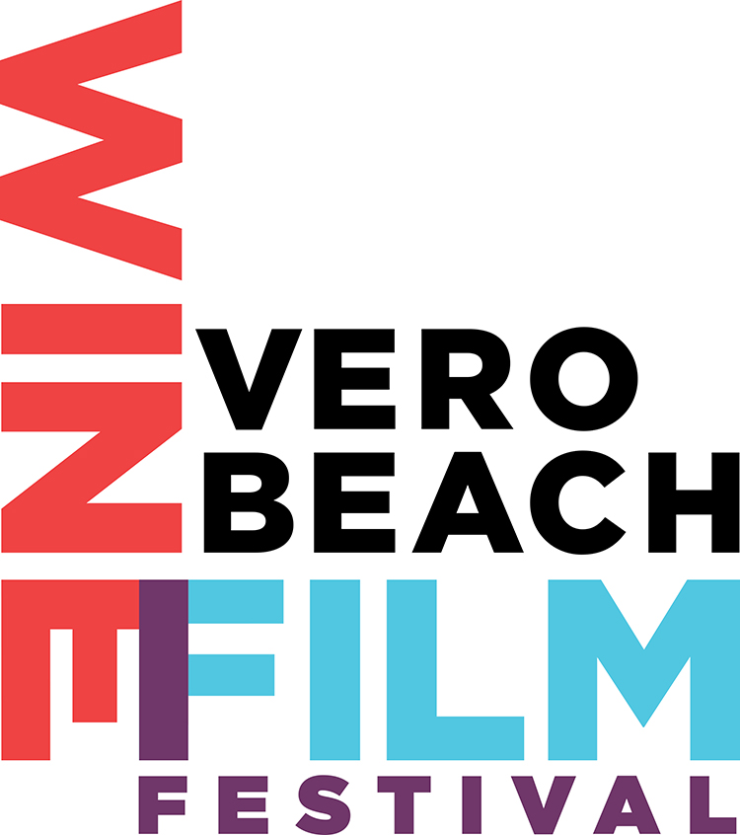
Top 10 Questions Asked About the
Vero Beach Wine + Film Festival
+ Bonus Question

- What is a Wine + Film Festival?
It is the weekend to drink great wines while watching wonderful films with good friends. See. Sip. Savor the experience.
The Vero Beach Wine + Film Festival is the ONLY wine and film festival in Florida.
It’s a four day, long weekend event where you’ll can see great independent films and enjoy a glass of wine with friends while seeing a movie. You can choose to see as many movies as you like and attend wine tastings over the course of the weekend with your Festival Pass.
Many of the films are award-winning and not in major distribution. And several of the wines to be poured are not yet available in Florida. Which means you won’t be able to enjoy them unless you attend the Festival.
See more information on the wine and films at our website: www.vbwff.com or www.verobeachwineandfilmfestival.com
- When is the Festival?
Thursday June 9 – Sunday June 12, 2016 It’s a 4 day event - a full-bodied long weekend of fine wines and remarkable independent films.
- Why June?
We’re the “end of season” celebration! June is the perfect month for both our residents and seasonal visitors to enjoy the community–wide screenings and parties. As restaurant reservations and hotel rooms are easier to come by then. And the Festival will add to the economic vitality of local businesses.
- Where is it?
The Festival takes place at 9 venues throughout Vero Beach – downtown and beachside. Major film screening venues are the Vero Beach Museum of Art and the Downtown Heritage Center. “Cinema Uncorked”, the opening night bash is at Riverside Theatre. There’s a complete list of venues on our website at www.vbwff.com or www.verobeachwineandfilmfestival.com

- What’s it for? Who does it benefit?
The Festival raises money for Suncoast Mental Health Center. The Center provides no cost and low cost mental health services to children and families in all 4 counties on the Treasure Coast – Indian River, St. Lucie, Okeechobee & Martin
- What kind of films will you show at the Festival?
We’ll screen independent feature, documentary and short films. Many of them have won awards from other Festivals from around the world.
These are films that our audiences wouldn’t otherwise have a chance to see, as most will not be playing on the big screen at your local movie theatre.
We’ll also show experimental & non-narrative films.
- What if I or a friend or my cousin has a film they’d like to show at the Festival?
We would love to consider their film. Please have them go to our website and click the “submit your film” link. Online at www.vbwff.com or www.verobeachwineandfilmfestival.com
- Where can I buy tickets?
Online at www.vbwff.com or www.verobeachwineandfilmfestival.com
- How much are tickets?
Passes which are good for all 4 days of the event are priced $95 - $2500 depending on which events you want to attend.
- Do you have a website?
www.vbwff.com or www.verobeachwineandfilmfestival.com
- Where did you get those great T-shirts?
Our Festival T-Shirts are printed by our Official Print Sponsor: Morningstar Custom Printing. Katie Gastley of Idlewild Co created the design And by popular request, they’ll be on sale soon at www.vbwff.com
The Festival has the support of many wonderful Vero Beach businesses and organizations: Treasure Coast Sotheby’s International Realty, Indian River Press Journal, TCPalm.com, Patisserie, Idlewild Co, Riverside Theater, Cultural Council of Indian River County, Regus, The Alexis Agency, Kite Tax Lien Capital, White Glove Moving & Storage, ORCA, Rotaract, and Vero Beach Art Club.

